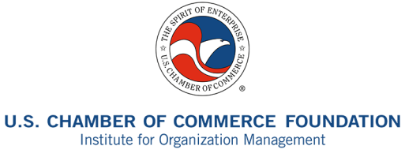

2014 Southeast Institute Silent Auction

100% of proceeds go to the Southeast Institute Scholarship Fund!!

Support your chamber, association, and nonprofit management colleagues by donating an item to the Institute for Organization Management silent auction.

Popular auction items include weekend getaways, sporting goods, gift cards, jewelry, and regional specialties. Get creative!

For more information about the Southeast Institute silent auction, please contact:

Randy Bradley, IOM
randy.bradley@scchamber.net
803-255-2611

Name: ___________________
Organization: ________________________________
Address: ___________________________________________________________________
City: ______________________________ State: ___________ Zip: __________________
Work Phone _____________________________ Cell Phone: ________________________
Email: ____________________________________________________________________

Item Description:

___________________________________________________________________________
_____________
Value: $ (Suggested minimum value: $25)

Thank you for your donation of property (described above) for the Institute for Organization Management’s charity auction. IOM is a program of U.S. Chamber of Commerce Foundation, a Section 501(c)(3) organization, and as such may receive tax-deductible charitable contributions. This confirms that no goods or services were provided in exchange for your contribution.

